Diabetic Retinopathy Detection using feedforward Neural Network
Jayant Yadav, Manish Sharma, Vikas Saxena
Computer Science and Engineering Department
Jaypee Institute of Information Technology
Sec-62, Noida, U.P., India

Abstract—Diabetic Retinopathy is an eye disorder which causes vision blurriness and blindness in diabetic patients. Currently, detection of Diabetic Retinopathy involves manual methods in which physical examination is done by a trained eye physician. This consumes a lot of time of the physician which could have been devoted to other patients. This paper tries to tackle this issue by using computer vision to not only detect this disease, but also automating this procedure using neural network to give results of many patients within a short time frame.
Keywords—Diabetic Retinopathy, Computer vision, Automation, neural network.

Introduction

Diabetic Retinopathy is one of the major reason that causes blindness. On an average, it affects 93 million people [1]. It affects almost 80 percent of the population who are suffering from diabetes for more than 20 years [2]. Studies have found that 90 percent of such cases can be eliminated if there exists a proper treatment and monitoring of eyes of the patients [3]. Chances of diabetic retinopathy in patient increases as he suffers more longer from diabetes [4].
Right now, detection of DR is manual and tedious process which needs a trained ophthalmologist to evaluate and examine digital photos of fundus images consisting of retina [1]. But until they give their reviews, i.e. few days later, these result in lost follow ups, delayed treatment and miscommunication [1]. So, there is a need for a screening using computer vision including image classification, pattern recognition and machine learning.

Experts identify Diabetic Retinopathy by looking for existence of lesions. These must be associated with eye abnormalities that was caused by the disease [1]. This method is effective yet very resource demanding. Since the number of diabetic patients are growing, so is the number of patients suffering from DR, which would require more infrastructure to prevent blindness among them [1].

Background
Non-proliferated diabetic retinopathy or NPDR is the first stag, in which there are no visible symptoms. The signs are not visible in the eye of the patients and they will have a 20/20 vision.
The region Macular, in which blood vessels leak their contents, can happen in any stage of NPDR. This causes Macular edema. Its symptoms consist of blurred vision and darkened or distorted images of objects. About 10% of the diabetic patients can have their vision loss due to this macular edema [5].
In the second stage, eye repairs itself to form abnormal new blood vessels at the back of the eye, which are very thin and fragile. So, these can burst and bleed (called vitreous hemorrhage) and blurs the vision even more. This forms a part of diabetic retinopathy.
The disease progresses that makes this severe non-proliferative diabetic retinopathy enter into an advance or proliferative (PDR) stage. In this stage too, the blood vessels proliferate and grow.
Current techniques of manual screening and detection of DR involves pupil dilation, Fluorescence Angiography, laser and Fundus camera.

Abbreviations and Acronyms
DR: Diabetic Retinopathy
DT: Dot Hemorrhages
SVM: Support Vector Machine

Concepts
- Morphological Transformations: These are simple operations which are operated upon images to manipulate them. It is done on binary images and requires two inputs, first is the original image and second is a kernel, also known as structuring element.
- Erosion: The basic idea is to erode away the boundary of the image. This is useful in the case where we have to remove small errors i.e., white noises, detach two connected objects etc. The pixel boundary is discarded depending upon the kernel size.
- Dilation: This is opposite of erosion; it increases the width of the object. If at least one pixel under the kernel is ‘1’, the size increases.

- Morphological Closing: It is useful to close small holes in the object as it applies Dilation followed by Erosion.
- Gaussian Blur: This function is used to blur the given image with the help of a gaussian filter. It does so by convolving the main image with a specified gaussian kernel.

Implementation
DR detection is being done by detecting two major parts of it, namely, Exudates (Fig 1) and Dot Hemorrhages (Fig 2). The overall architecture of the implemented model is represented in Fig 3.
First, we will do the preprocessing in following ways:
- Extracting Optic Disk
- Extracting Blood Vessels
- Detection of Exudates
- Detection of Dot hemorrhages
This step is followed by training the dataset [8] using machine learning, which is by applying neural networks.

Preprocessing Stage

1) Extraction of Optic Disk:

a) Various methods are tested, as given by various papers. Finally, a different method is invented.

b) Image in Green channel is extracted from its original, since yellow color is high in green channel and optic disk is yellow in color [6].

c) Thresholding is done in the range of 200 to 250 [6].

d) contours are detected to encompass yellow regions and they are they labelled according to their size.

e) Since optic disk is greatest in size, this contour is selected.

f) A circle is drawn around the contour This circle is closest fitting circle.

g) Another circle is drawn, with radius 1.5X of the previously drawn circle. This is to insure that it encompasses the whole optic disk.

h) A mask is drawn with this circle.

i) This mask is then deleted from the original image.
Output is shown in Fig 4.

2) Extraction of Blood vessels:
a) Image in Green channel is extracted from its original, since red color is high in green channel and blood vessels are in red color.
b) Two different kernels are made of varying sizes.
c) Two different morphological closing are applied on the images using those two kernels.
d) A gradient image is made by subtracting the kernel image and the original green channel image.

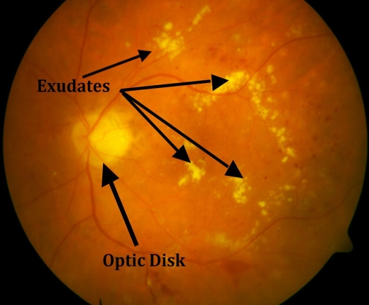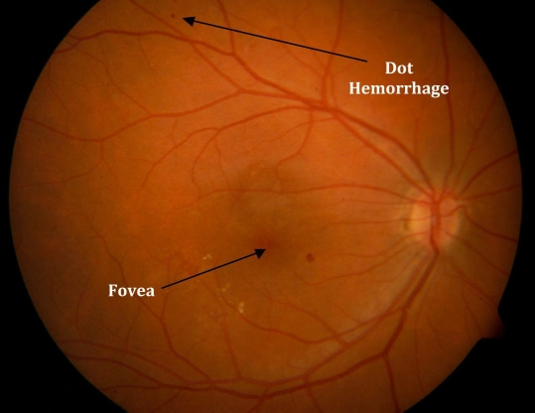
Fig 1: Exudates[7] Fig 2:Dot Hemorrhages[7]

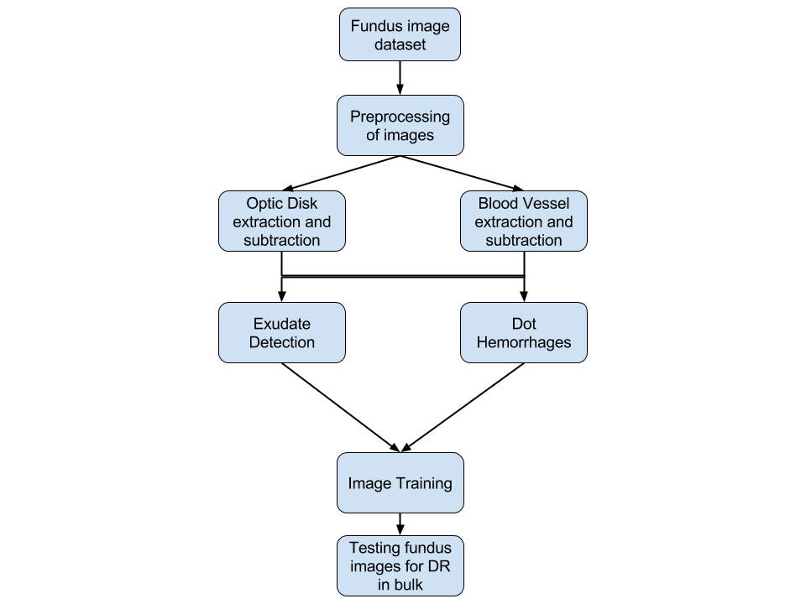
Fig 3: Overall architecture

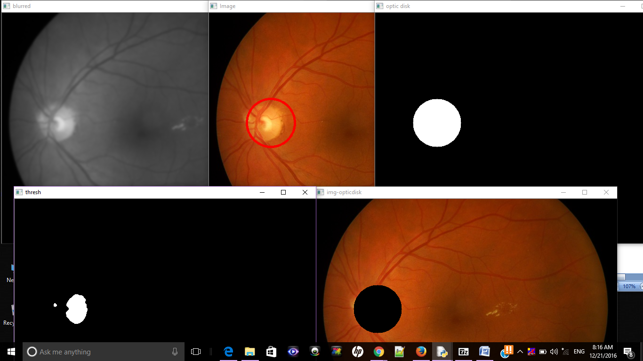
Fig 4: Optic Disk Detection

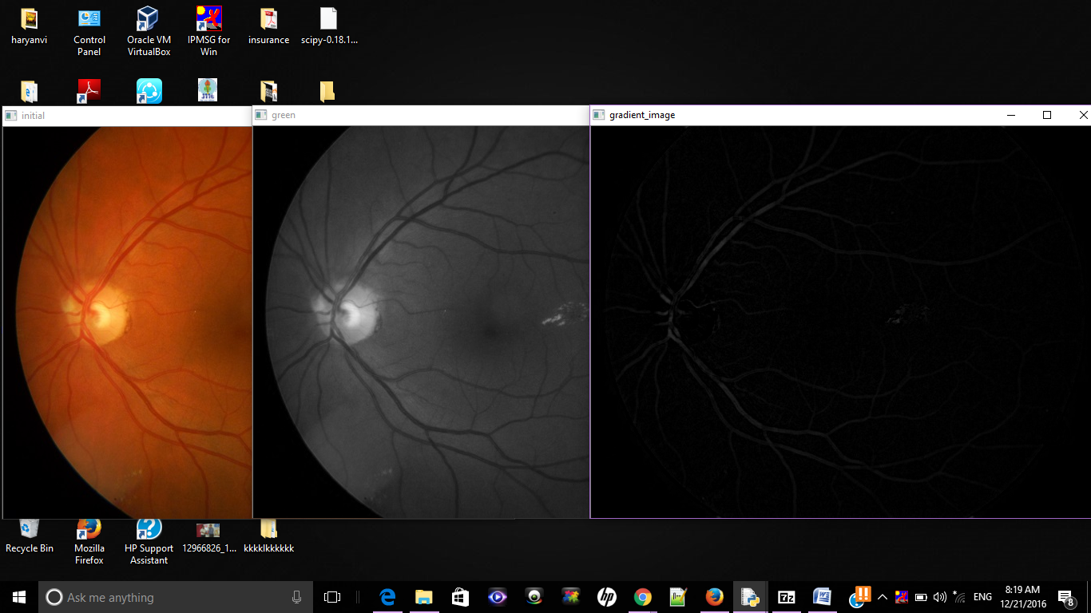
Fig 5: Gradient Image (Blood Vessel Detection)

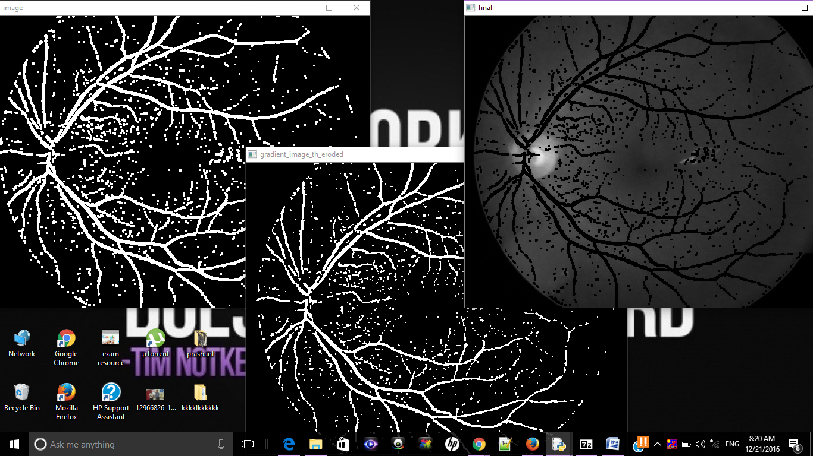
Fig 6: Gradient Image after Thresholding (Blood Vessel Detection)

e) Threshold is applied on the resultant image to get a binary image as an output. The rage of the threshold will vary according to the quality of images in the
dataset. For now, it is hardcoded for the available dataset to 2,255.

f) This image is then subtracted from the green channel image to give the desired result.
Output is shown in Fig 5 and Fig 6.

3) Detection of Exudates:
a) Two kernels are generated and then applied to the green channel image, since exudates are yellow in color.
b) Dilation of the morphological operation is used on two separate images using one kernel each.
c) Subtraction of the resultant two dilated images are done to highlight the edges of the yellow exudates in the fundus image.
d) Thresholding is done for better contrast.
e) Blood vessels and optic disk detected previously are removed from the resultant image to get the exudates.
Output is shown in Fig 7.

4) Detection of Dot Hemorrhages:
a) A binary image is created by calculating red/green (R/G) intensities from the given fundus image.
b) A 50-pixel median filter is applied to the resultant.
c) Subtracting Red/Green ratio image and the resultant image.
d) Applying threshold to the resultant image so that the red component of the fundus is visible clearly.
e) The resultant image is converted into binary image and taken compliment of it.
f) Canny edge detection is applied to the resultant image to highlight the dots in DHs.
Output is shown in Fig 8.

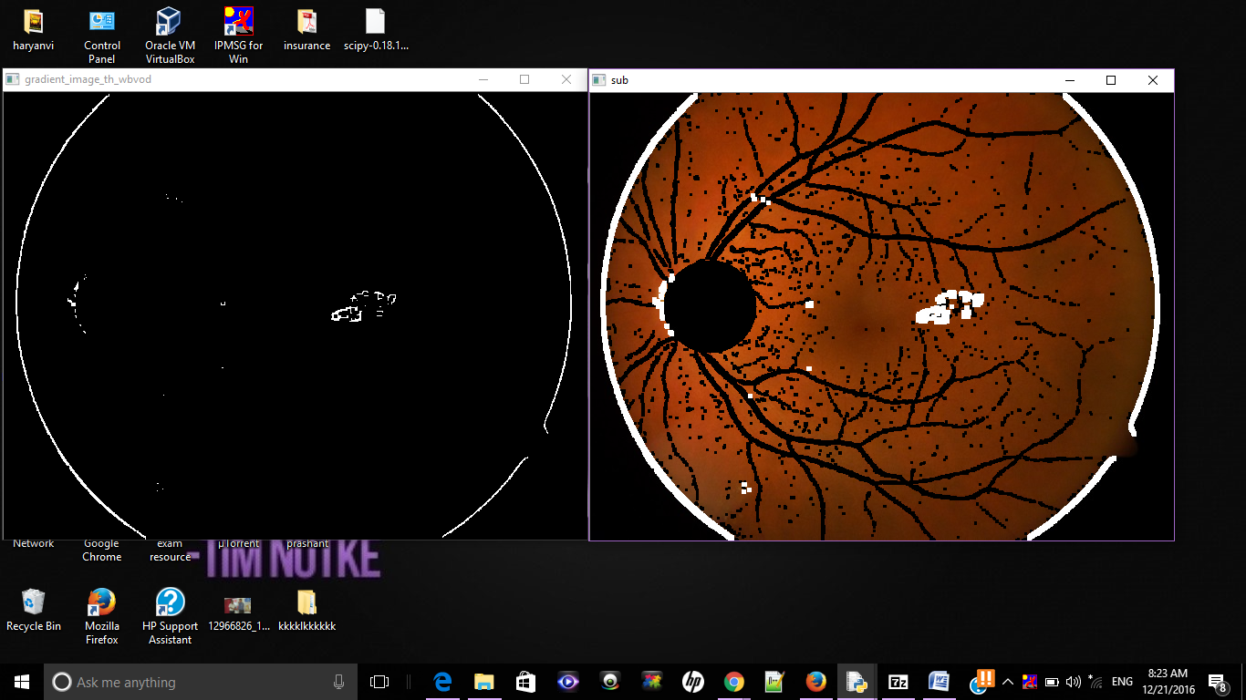
Fig 7: Exudate Detection

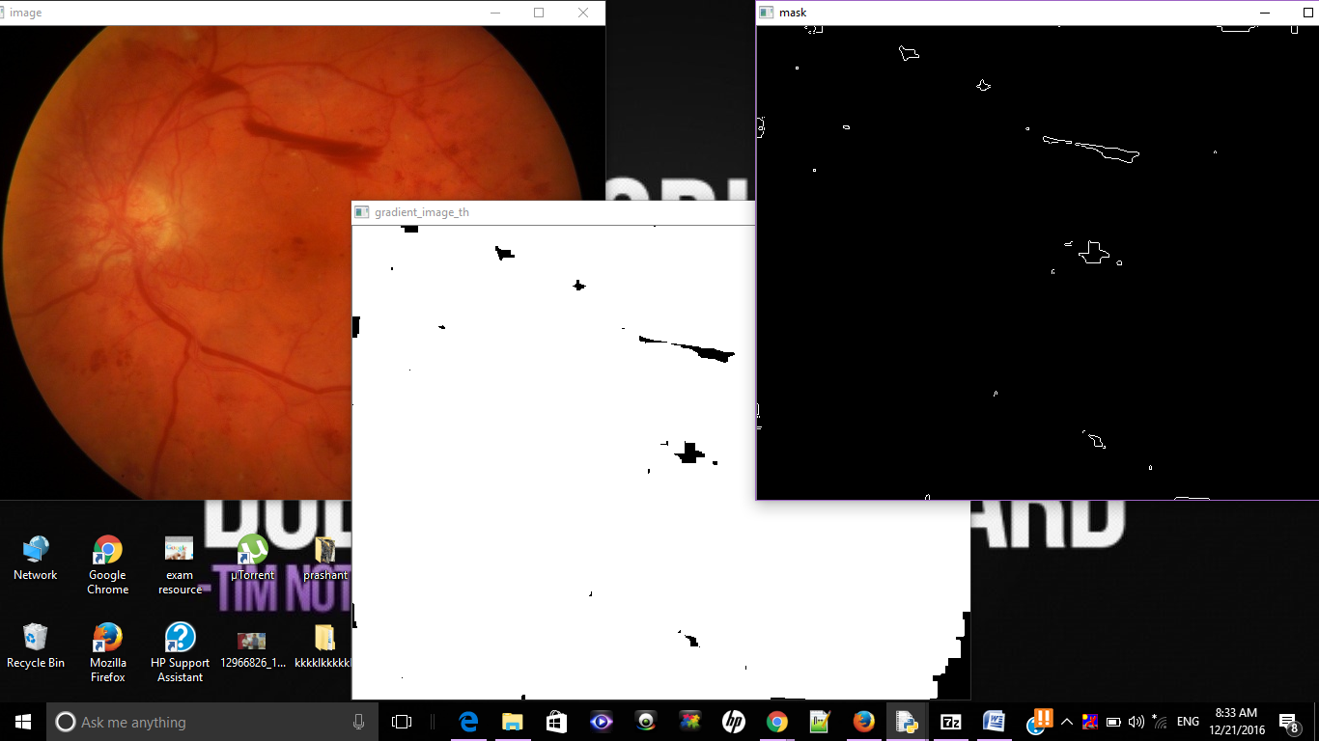
Fig 8: Dot Hemorrhages

Machine Learning Stage
- The images to be trained are divided into 4 categories namely:
  - normal
  - dot hemorrhages
  - exudates
  - both
- Take the image paths and use preprocessing on them in order to distinguish their features among themselves
- Reduce the resolution of the images to train them
- Flatten the images into raw pixel intensities
- Convert the labels from string to integers, into a vector where i-th index is 1 and others are zero
- The architecture of the network is consisting of 4 layers:
  - 1st layer is the number of features in the image: 128x128x3. Since there are three channels RBG
  - 2nd layer is the hidden layer and has 768 filters this number must be between number of input and output.
  - 3rd layer is again a hidden layer having 384 filters
  - 4th layer is the output layer which has 4 outputs corresponding to 4 classes of DR.
- The output is an array of probabilities for a specific image. The softmax function is applied to get the max of the probabilities. •
- Stochastic Gradient descent is applied to get the accuracy of each images. It is run for 50 epochs with 4 as its batch size.
The training set has 192 images, testing set has 64 images. Output for training set is in Table I.
Output for testing set is in Table II.

Table I: Training Results
Epoch No | Loss | Accuracy
10 | 0.5400 | 0.7500
20 | 0.5321 | 0.7500
30 | 0.5274 | 0.7500
40 | 0.5259 | 0.7500
50 | 0.5230 | 0.7500
Table II: Testing Results
Loss | Accuracy
0.5647 | 75.00%

Acknowledgment
We would like to thank all the authors from whose paper we have gained knowledge about the subject and used their findings to carry forward our work. We would also like to thank Ophthalmologist from AIIMS, India with whose valuable input, we gained much insight into the current clinical methods which are being applied to Diabetic patients.

References
- https://www.kaggle.com/c/diabetic-retinopathy-detection
- Kertes PJ, Johnson TM, eds. (2007). Evidence Based Eye Care. Philadelphia, PA: Lippincott Williams & Wilkins. ISBN 0-7817-6964-7
- Tapp RJ; Shaw JE; Harper CA; et al. (June 2003). "The prevalence of and factors associated with diabetic retinopathy in the Australian population". Diabetes Care. 26 (6): 1731–7. doi:10.2337/diacare.26.6.1731
- Caroline MacEwen. "diabetic retinopathy". Retrieved August 2, 2011.
- “Nonproliferative Diabetic Retinopathy (Includes Macular Edema)". Retrieved August 17, 2013
- Anupriyaa Mukherjeeet al. Int. Journal of Engineering Research and Applications ISSN : 2248-9622,Vol. 5, Issue 2, ( Part -4) February 2015, pp.21-24
- Hann, Christopher E., James A. Revie, Darren Hewett, J. Geoffrey Chase, and Geoffrey M. Shaw. "Screening for diabetic retinopathy using computer vision and physiological markers." Journal of diabetes science and technology 3, no. 4 (2009): 819-834.
- http://www.it.lut.fi/project/imageret/diaretdb1/

